Research Proposal
(1400-1700 words)
Thesis Title: (A clear, summarizing title that reflects the study's goal.)

Name:

Under the supervision of:

1 | Prof./ Type the full name  Professor, Renewable Energy and Engineering Department,  Faculty Postgraduate Studies for Advanced Sciences (PSAS),  Beni-Suef University (BSU), Egypt.
2 | Assoc. Prof./ Type the full name  Assoc. Professor, Biotechnology and Life Sciences Department,  Faculty Postgraduate Studies for Advanced Sciences (PSAS),  Beni-Suef University (BSU), Egypt.
3 | Dr./ Type the full name  Lecturer, Biotechnology and Life Sciences Department,  Faculty Postgraduate Studies for Advanced Sciences (PSAS),  Beni-Suef University (BSU), Egypt.

- Abstract (250 – 350 words)
A brief summary of the research background, objectives, methods, and expected outcomes.
Keywords: XXXXX; XXX; XXXX. (3 to 6 keywords)

- Introduction/ Background
Introduce the general topic. Clearly identify the Research Problem/Statement, and define the gap in knowledge the study will address. Explain the research significance. Cite the references.

- Aims of the study/ Objectives
Mention the general aims and the specific objectives.

- Methodology
Describe the methodology to be used in the proposed research and why it is appropriate to achieve the research objectives. Cite the references.

- Expected outcomes
Possible outcomes including publications and/or patents.

- Work Plan
Outline the timeline of the main research tasks (a schedule or a simple Gantt chart).

- Ethical considerations (if applicable)
If human or living animals are involved directly in the proposed research, mention the actions that will be taken to ensure compliance with ethics guidelines.

- References
Adhere to only one style for citing references.


Sustainable Development Strategy SDS symbolizes the roadmap for maximizing competitive benefit to achieve the thoughts and aspirations of Egyptians in a decent life.
It also denotes an example of the new constitution’s essence, setting wellbeing and wealth as the main economic objectives, to be achieved via sustainable development, social justice and a balanced, geographical and sectoral growth.
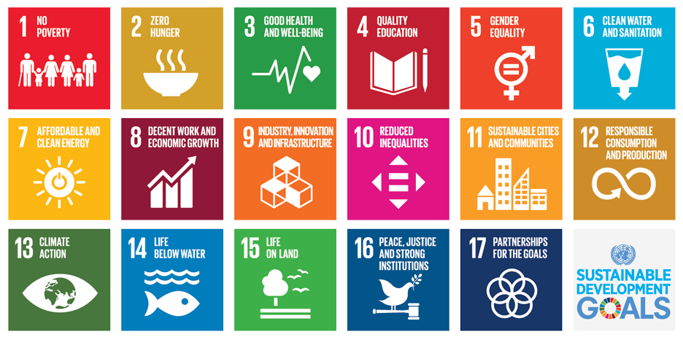
Based on our distinguished research tracks and uniqueness of our faculty (PSAS) as a prototype of research educational platform that was founded at 2013, we follow the SDGs as we have 4 departments: Environmental Science and Industrial Development, Renewable Science and Engineering- Biotechnology and Life Sciences, Materials Science and Nanotechnology.
Choose 2 SDGs (sustainable development goals) that are achieved through the proposal + SDG 17 is mandatory:
GOAL 1: No Poverty
GOAL 2: Zero Hunger
GOAL 3: Good Health and Well-being
GOAL 4: Quality Education
GOAL 5: Gender Equality
GOAL 6: Clean Water and Sanitation
GOAL 7: Affordable and Clean Energy
GOAL 8: Decent Work and Economic Growth
GOAL 9: Industry, Innovation and Infrastructure
GOAL 10: Reduced Inequality
GOAL 11: Sustainable Cities and Communities
GOAL 12: Responsible Consumption and Production
GOAL 13: Climate Action
GOAL 14: Life Below Water
GOAL 15: Life on Land
GOAL 16: Peace and Justice Strong Institutions
GOAL 17: Partnerships to achieve the Goal (regional- national- international) collaborations and funds (submitted projects- accepted).

